A Car Made In Water Fall Module and Agile Module

The waterfall model is a classical model used in system development life cycle to create a system with a linear and sequential approach. It is termed as waterfall because the model develops systematically from one phase to another in a downward fashion.

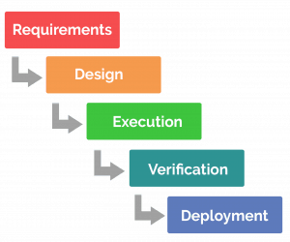

A Car made in Water Fall Module

**Conceptual Design**: Start by defining the purpose and features of your car. Consider how you want the waterfall module to function and what benefits it should provide, such as energy generation, cooling, or aesthetic appeal.

**Research and Development**: Research existing water-related technologies that could be integrated into your car's design. This might include hydroelectric generators, water cooling systems, or decorative water features.

**Engineering and Integration**: Work with engineers and designers to integrate the waterfall module into the car's overall design. This may involve designing custom components, such as water channels, reservoirs, and pumps, to fit within the vehicle's chassis and body.

**Testing and Iteration**: Prototype and test the waterfall module to ensure it functions as intended and meets safety and performance standards. Iterate on the design as needed to optimize performance and reliability.

**Manufacturing**: Once the design is finalized, manufacture the components of the waterfall module and integrate them into the car during the assembly process.

**Quality Control and Testing**: Conduct thorough quality control checks and testing on the completed car to ensure all components, including the waterfall module, are functioning

**Marketing and Launch**: Prepare for the marketing and launch of your car, highlighting the unique features and capabilities of the waterfall module to attract customers.

**Maintenance and Support**: Provide maintenance and support services for the car, including regular maintenance for the waterfall module and troubleshooting assistance for any issues that arise.

**Outcome:** If we make a car in waterfall module it may rise many problem if the customer does not like the outcome of the car we have to rebuilt the car and it is also waste of time waste of energy and waste of money**.**

**A Car Made in Agile Module:**

Agile Modeling (AM) is a collection of values, principles, and practices for modeling software that can be applied on a software development project in an effective and lightweight manner.

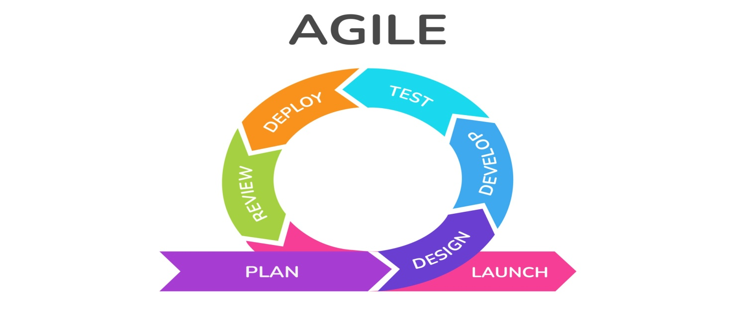

**Define the Product Vision**: Start by defining the overall vision and goals for the car. This could include factors like target market, key features, performance metrics, and sustainability goals.

**Create a Product Backlog**: Collaborate with stakeholders to create a prioritized list of features and requirements for the car. This backlog will serve as the roadmap for development, with items prioritized based on value and feasibility.

**Iterative Development**: Break down the development process into small, manageable iterations or sprints, typically lasting 1-4 weeks. Each sprint focuses on delivering a specific set of features or improvements to the car.

**Cross-Functional Teams**: Form cross-functional teams consisting of engineers, designers, marketers, and other relevant stakeholders. These teams work together closely to deliver value in each sprint.

**Daily Stand-up Meetings**: Hold daily stand-up meetings (or "daily scrums") to keep the team aligned and address any obstacles or blockers. During these meetings, team members share updates on their progress, discuss challenges, and coordinate efforts.

**Iterative Design and Prototyping**: Use rapid prototyping techniques to quickly design and test different iterations of the car. Solicit feedback from users and stakeholders early and often to inform design decisions.

**Continuous Integration and Testing**: Implement continuous integration practices to ensure that changes to the car's software and hardware are integrated and tested regularly. Automated testing can help maintain quality while allowing for rapid iteration.

**Regular Review and Retrospective Meetings**: At the end of each sprint, conduct a sprint review to demonstrate the work completed and gather feedback from stakeholders. Follow up with a sprint retrospective to reflect on what went well, what could be improved, and any adjustments needed for future sprints.

**Adaptation and Flexibility**: Embrace change and be willing to adapt plans and priorities based on feedback and new information. Agile methodologies prioritize responding to change over following a rigid plan.

**Continuous Improvement**: Continuously assess and improve the development process based on feedback and performance metrics. Regularly revisit the product backlog to reprioritize features and adapt to evolving market needs.

